Practical 1
Name : Soumya Dixit PRN : 23070521151
Semester : 4th Section : B Batch : B2

Task 2 : Design and ER Diagram and Relational Model for the following problem statement ( Smart Healthcare Management System )

Patient
Patient ID | Name | Age | Gender | Contact  information | Address
22300768 | Disha | 23 | female | 9999999990 | jaipur
.. | .. | .. | .. | .. | ..
.. | .. | .. | .. | .. | ..

Treats
Doctor ID | Patient ID
11112222 | 22300768
.. | ..
.. | ..

Doctor
Doctor ID | Name | Specialty | Qualification | Work  Schedule | Contact  Information
11112222 | Prakash | Dermatologist | MD in  Dermatology | 8 AM – 8 PM | 9999988880

Medication
Medication ID | Manufacture | Name | Dosage | Expiry Date
0000022 | xxx | aaa | 2 or 3 times a day | 11-Mar-20XX
.. | .. | .. | .. | ..
.. | .. | .. | .. | ..

Appointment
Appointment ID | date | time | Reason to visit | status
212121 | 10 – Jan – 22XX | 3 PM | Acne | revisit
.. | .. | .. | .. | ..
.. | .. | .. | .. | ..

Room
Room ID | Room type | Availability Status
000022 | single | Available
.. | .. | ..
.. | .. | ..

Billing
Patient ID | Bill ID | Appointment ID | Total amount | Payment Status
22300768 | Aa00023 | 212121 | 2,300 | URL
.. | .. | .. | .. | ..
.. | .. | .. | .. | ..

Staff
Staff ID | Name | Role | Assigned Department
5555 | qqq | Nurse | Derma
.. | .. | .. | ..
.. | .. | .. | ..

Equipment
Equipment ID | Name | Type | Assigned  Department | Maintenance  Schedule
4444 | ee | rr | Derma | Every Monday at  2 PM
.. | .. | .. | .. | ..
.. | .. | .. | .. | ..

Manages
Staff ID | Equipment ID
5555 | 4444
.. | ..
.. | ..

Handle
Staff ID | Billing ID
5555 | Aa00023
.. | ..
.. | ..

Allotted
Room ID | Patient ID
000022 | 22300768
.. | ..
.. | ..

Has
Patient ID | Appointment ID
22300768 | 4444
.. | ..
.. | ..
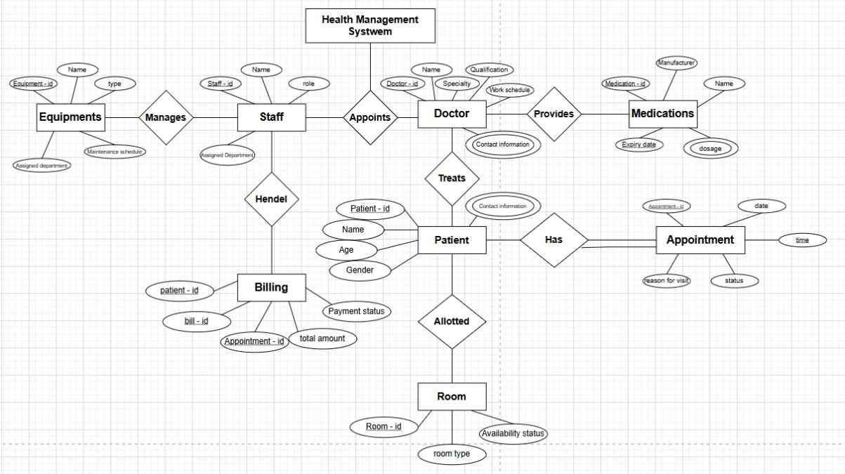

Task 3 : Draw EER Diagram and Relational Model for Bank Management System

Customer
Customer ID | Name | Address | Email | Phone
222 | ss | xyz | ab@gmail | 3322332233
.. | .. | .. | .. | ..
.. | .. | .. | .. | ..

Account |  |  |  | Is a
Interest rate | Balance | Account ID | Type | Checking (Over draft  limit) | Saving ( minimum balance )
7 % | 67,000 | Aa223 | saving | .. | 35,000
.. | .. | .. | .. | .. | ..
.. | .. | .. | .. | .. | ..

Transacti  on |  |  |  |  | Is a
Transacti on ID | Dat e | Account |  | Amou nt | Transf er | Withdra wal | Depos it
 |  | Source | Destinati  on
223333 | 23–  Mar –  20x | aa | bb | 50,000 | 2,000 | .. | ..
.. | .. | .. | .. | .. | .. | .. | ..

Employee |  |  | Is a
Employee ID | Name | Assigned  branch | Manager  (department) | Teller
Ww333 | nn | pp | pp | ..
.. | .. | .. | .. | ..
.. | .. | .. | .. | ..

Branch
Branch ID | Location | Phone number
pp | ii | 2121212121
.. | .. | ..
.. | .. | ..

Loan Management
Instalment ID | Instalment date | Instalment amount
33aa4 | 22-Feb-2000 | 5,00,000
.. | .. | ..
.. | .. | ..

Loan
Loan ID | Interest  rate | Loan  amount | Start date | End date | Status
8888 | 8% | 8,00,000 | 8-Aug-  2020 | 7-Aug-  2022 | Unpaid
.. | .. | .. | .. | .. | ..
.. | .. | .. | .. | .. | ..

Perform
Account ID | Transaction ID
Aa223 | 223333
.. | ..

Involves
Customer ID ^{m} | Transaction ID ¹
222 | 223333
.. | ..

Owns
Customer ID ^{n} | Account ID ¹
222 | Aa223
.. | ..

Associated
Customer ID | Branch ID
222 | pp
.. | ..

Managed by
Branch ID | Employee ID
pp | Ww333
.. | ..

Applies
Customer ID | Loan ID
222 | 8888
.. | ..

